8. Project Demonstration Phase
Project: Implement Client Script & UI Policy (ServiceNow)

Phase Objective
The final phase demonstrates the completed project flow. The final form, configured values, visible results, and overall project outcome are shown as evidence of the implementation.

Activities Covered
- Show the completed implementation.
- Demonstrate the final form behavior.
- Present the project outcome using the recorded screens.

Screenshots from the Project Video
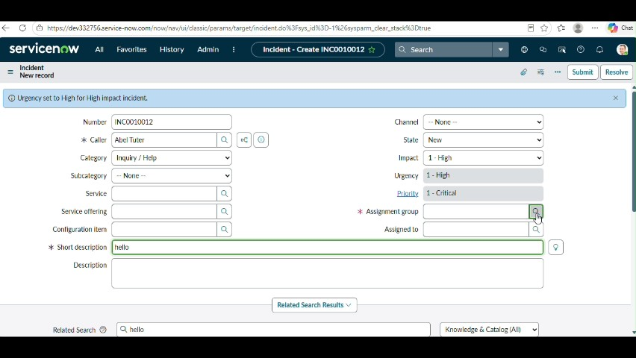
Figure 1: Project video screen at approximately 450 seconds.
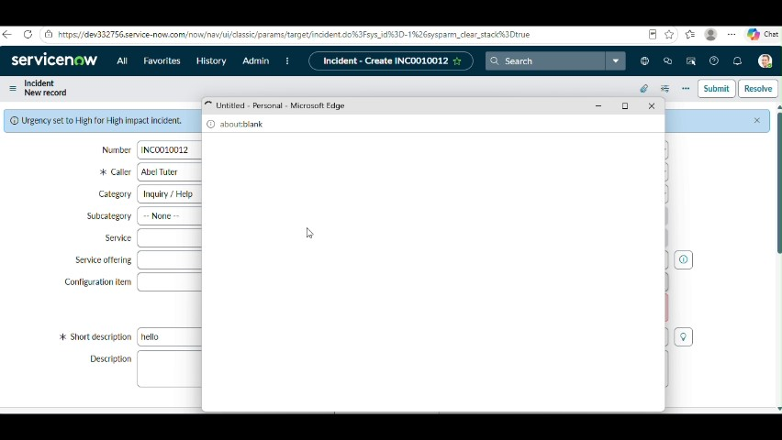
Figure 2: Project video screen at approximately 468 seconds.
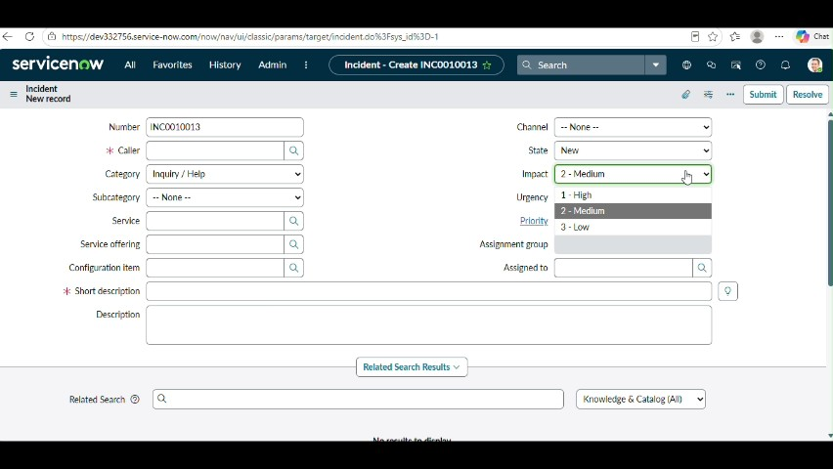
Figure 3: Project video screen at approximately 486 seconds.
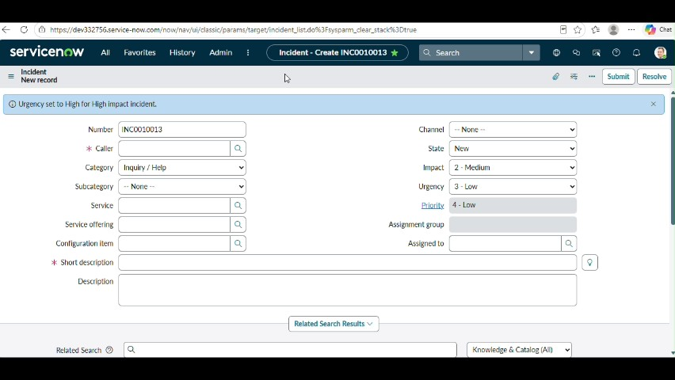
Figure 4: Project video screen at approximately 504 seconds.
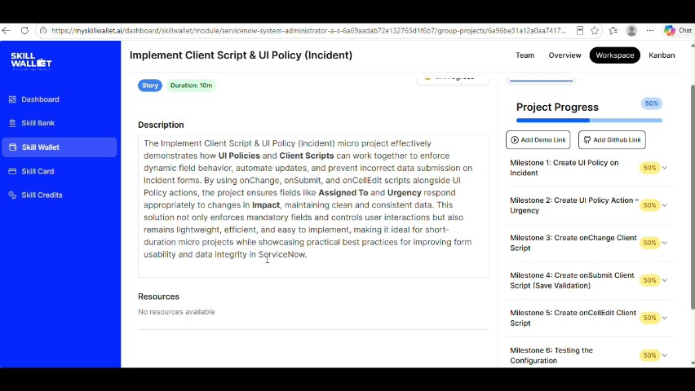
Figure 5: Project video screen at approximately 522 seconds.

Phase Outcome
The completed project is presented through the final form and demonstrated behavior.
Prepared from the supplied project demonstration video

